# **Condition: File Share Storage high utilization**

**Condition**

**Description:**

* Azure File Shares are cloud based shares accessible through SMB protocol, which can be mounted on cloud or on-premises deployments of Windows, Linux etc.
* All file shares have a fixed quota (size) assigned to them in GBs and depending upon the usage of file share, we need to trigger alerts at specific threshold percentage utilizations.

**Impact:** Any Azure component or services using File share at the backend won’t be able to add more content to the File share if it is full, which might impact the overall functioning of the application or the service

**Criticality:** Critical Impact for Error threshold & Non-Critical Impact for Warning threshold

**Frequency:** 30 or 60 min

**Trigger Details**

**Trigger Condition:** Alerts will be triggered on basis of following ‘Percentage Free Space’ ranges mentioned below.

| **Volume Size in GB** | **Value of X (Warning)** | **Value of X (Error)** | **Value of (Closing)** |
| --- | --- | --- | --- |
| **>20 and < = 100** | 10 % | 5% | 15% |
| **>100 and < = 250** | 8% | 4% | 12% |
| **>250 and < = 500** | 6% | 3% | 9% |
| **> 500 and < = 1024** | 4% | 2% | 6% |
| **>1024 and above** | 2% | 1% | 3% |

**Method to capture trigger point:**

* Capture the Quota assigned property of File Share by REST API mentioned below

https://**{NameOfStorageAccount}**.file.core.windows.net/**{NameOfFileShare}**?restype=share

* The above REST API call will return a Response header with a property: **‘x-ms-share-quota’** which is the File Share quota in GBs.
* **Sample Response Header:**

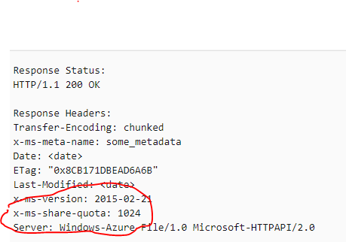

* Now, we will make another REST API call to the File share to obtain the File share statistics, using the following REST endpoint.  
  https://**{NameOfStorageAccount}**.file.core.windows.net/**{NameOfFileShare}**?restype=share&comp=stats

* Above call will return a XML response body with property tag: **‘<ShareUsageBytes>8189134192<ShareUsageBytes>’** which will hold the Bytes used by the File share.   
    
  **Sample Response Body:**  
    
  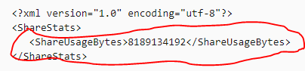
* Now usage from the above step and the quota captured from the first step can be used to calculate the percentage utilization of the File share and to trigger an alert if threshold is breached.

**REST API Reference:**

<https://docs.microsoft.com/en-us/rest/api/storageservices/get-share-properties>

<https://docs.microsoft.com/en-us/rest/api/storageservices/get-share-stats>

**Alert Details**

**Alert Category:** Storage account \ File share

**Details required along with Alert:**

1. Subscription ID.
2. Resource Group Name.
3. Storage Account Name.
4. File Share Name
5. File Share Quota
6. File Share Utilization Percentage
7. File Share Free Space